BIOLOGY

CHAPTER 1

Lecture prepared by: Waleed Zahoor

Team Roshni
Step-up Pakistan

CELLS: THE BUILDING BLOCKS OF LIFE

LEARNING OBJECTIVES:

- Identify the various components of plant and animal cells visible under a light microscope.
- Compare and contrast the structure of plant and animal cells.
- Appreciate the importance of the cell surface membrane.
- Differentiate between the terms cell, tissue, organ and organ system.

A cell is a basic unit of life. It consists of a mass of living matter called protoplasm.

PROTOPLASM:
It is a complex jelly-like substance in which several chemical reactions take place. Water forms 70% to 90% of the total protoplasm, whereas the rest of it comprises of mineral salts and basic organic compounds (carbohydrates, proteins and fats). The composition of protoplasm is not the same for all the cells as it is a mixture. Composition of the protoplasm of muscle cells may be different from the composition of protoplasm of the cells in the lungs.

The protoplasm of a cell consists of 3 main parts:
- Nucleus
- Cytoplasm
- Cell surface membrane.

The diagram below shows a typical animal cell with the main parts of a cell labeled along with other organelles.

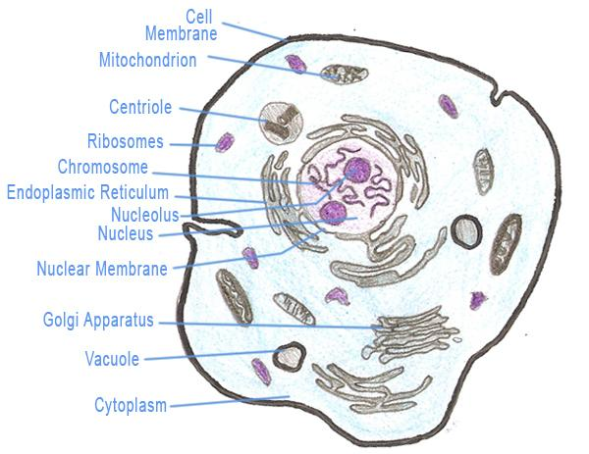
The diagram below shows a typical plant cell with the main parts of a cell labeled along with other organelles.

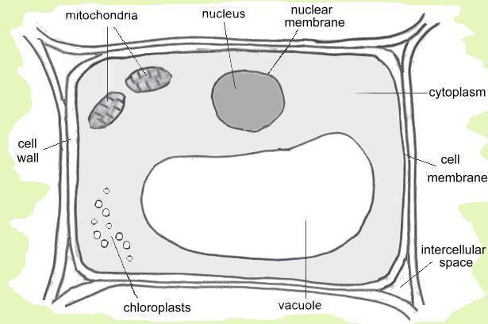

- Nucleus:
The nucleus is a membrane bound structure that contains the cell's hereditary information and controls the cell's growth and reproduction. It is commonly the most prominent organelle in the cell.
The nucleus is surrounded by a structure called the nuclear envelope. This membrane separates the contents of the nucleus from the cytoplasm. The cell's chromosomes are also housed within the nucleus. Chromosomes contain DNA which provides the genetic information necessary for the production of other cell components and for the reproduction of life. There are also some spherical structures called nucleoli. Each nucleolus plays a part in the building of the proteins.

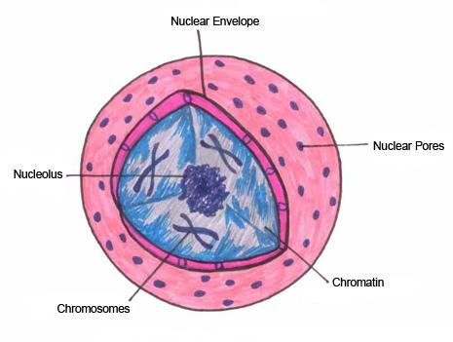

- Cytoplasm:
The part of the protoplasm surrounding the area around the nucleus is called cytoplasm. It forms the largest part of the cell and is the place where most life processes occur. Following are some of the important organelles in the cell which are embedded in the cytoplasm.

- Mitochondria:
Mitochondria are small spherical or rod-shaped organelles. The main function of the mitochondrion is the production of energy, in the form of adenosine triphosphate (ATP). The cell uses this energy to perform the specific work necessary for cell survival and function.

- Centriole:
A centriole is a pair of tiny structures close to the nucleus. They play a part in cell division and are absent in most of the plant cells.

- Vacuole:
A vacuole is a membrane-bound sac that plays roles in intracellular digestion and the release of cellular waste products.
      - Animal cells may have many small vacuoles which are usually not permanent. Vacuoles may contain water and food substances.
      - A plant cell has a large central vacuole which contains a liquid called cell sap. It contains dissolved substances such as sugar, mineral salts and amino acids. This large vacuole is enclosed by a membrane called the tonoplast.

- Cell surface membrane:
The cell surface is surrounded externally by a cell surface membrane, also called the plasma membrane. It is a partially permeable membrane which allows only certain substances to leave or enter the cell. Similar membranes may also surround large spaces or vacuoles within the cell

- Cell wall:
In a plant cell, there is a cell wall which encloses the whole cell. The cell wall is made of cellulose. It gives the cell structural support and is completely permeable. It protects the cell from injury.

- Chloroplasts:
Chloroplasts are specialized organelles found in all higher plant cells. These organelles contain the plant cell's chlorophyll, hence provide the green color. They assist the plant in the process of photosynthesis.

- Plastids:
Plastids are major organelles found in the cells of plants and algae. Plastids are the site of manufacture and storage of important chemical compounds used by the cell. Plastids often contain pigments used in photosynthesis, and the types of pigments present can change or determine the cell's color

DIFFERENCES BETWEEN PLANT AND ANIMAL CELLS

Animal Cell | Plant Cell
Shape: | Round (irregular shape) | Rectangular (fixed shape)
Chloroplast: | Animal cells don't have chloroplasts | Plant cells have chloroplasts because they make their own food
Vacuole: | One or more small vacuoles (much smaller than plant cells). | One, large central vacuole taking up 90% of cell volume.
Centrioles: | Present in all animal cells | Only present in lower plant forms.
Plastids: | Absent | Present
Cell wall: | Absent | Present
Plasma Membrane: | only cell membrane | cell wall and a cell membrane

SPECIALIZED CELLS, TISSUES, ORGANS AND ORGAN SYSTEMS

DIFFERENTIATION:
This is the process in which a cell is specialized for a specific function. For example, human cells become differentiated to form various types which include liver cells, muscle cells, sperm cells etc. whereas plant cells in roots and stems become differentiated to form different types of cells including xylem cells and phloem cells.

MODIFICATION OF CELL STRUCTURES FOR SPECIFIC FUNCTIONS:

- Root hair call:

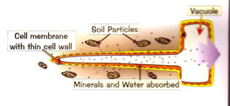

Being long and narrow, the root hair increases the surface area to volume ratio of the cell for efficient absorption of water and mineral salts from the soil. The thin cell wall also speeds up the absorption process.

- Red blood cell:

Thin central portion
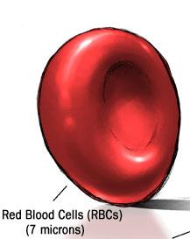

The red blood cell contains a red pigment called hemoglobin which enables the cell s to transport oxygen from the lungs to all parts of the body. Its circular, biconcave shape increases surface area to volume ratio. As a result, oxygen can diffuse into and out of the cell at a faster rate.

TISSUES, ORGANS AND SYSTEMS

- TISSUE:
A tissue is a group of cells which have a common origin and a similar structure, which enables them to perform a particular function. Some examples include: connective tissues, muscle tissues etc.

- ORGANS:
An organ is a group of different tissues working together and enabling the organ to perform its functions. The stomach for example is made from glandular tissues, muscular tissue and connective tissues along with nervous tissue. Other examples of organs include brain, intestines and the kidneys. Some plant organs include leaf, stem, root etc.

- ORGAN SYSTEMS:
Several organs working together for a special purpose make up an organ system. Some examples of organ systems are: the respiratory system, the digestive system and the endocrine system.

